 | Assignment No. 03  Semester: Fall 2021  CS304- Object Oriented Programming |  | Total Marks: 20  Due Date: 15/02/2022
Objective
The objective of this assignment is:
To give you the idea of practical implementation of C++ Inheritance and Polymorphism.

Uploading instructions:

- Your assignment should be in .CPP format (Any other formats like scan images, PDF, zip, doc, rar and bmp etc. will not be accepted).
- Save your assignment with your ID (e.g. bc000000000.CPP).
- No assignment will be accepted through email.

Rules for Marking:

It should be clear that your assignment will not get any credit if:

- The assignment is submitted after due date.
- The submitted assignment does not open, execute or file is corrupted.
- Your assignment is copied from internet, handouts or from any other student.
(Strict disciplinary action will be taken in this case).

Lectures Covered:

This assignment covers Lecture # 23 - 29.

Assignment No. 03
Consider that a school “ABC” hired you as a programmer to maintain the record of its Students and Teachers. You need to develop a system in C++ to enter the data and show it as and when required.
Keeping in the view above scenario, you are required to write a C++ program that can display the information of any specific Teacher or the Student. It will contain following three classes:
- Person
- Teacher
- Student
- where a Person should be the base class and Teacher and Student should be its derived classes.
You are required to use the concept of Polymorphism to generate the sample output. Consider following class table for above scenario.

Class | Data Members | Member Functions
Person | - Name  - Age  - Gender  - Address  - Phone | - Default Constructor  - Setter and getter functions for all the data member.  - A function to save information of a person  - A function to display information of a person
Teacher | - Qualification  - Salary | - Default Constructor  - Setter and getter functions for all the data members  - A function to save information of a Teacher  - A function to display information of a Teacher.
Student | - Previous Education  - Obtained marks  - Total Marks | - Default Constructor  - Setter and getter functions for all the data members  - A function to save information of a Student.  - A function to display information of a Student.

Solution Guidelines:
- Create three classes: Person as a base class and Teacher and Student as derived classes.
- You have to create the default constructor for each class.
- You have to create the setter and getter functions for each attribute of Person class.
- You have to create Save_Information function for each class as mentioned in the table.
- You have to create Display_Information function for each class as mentioned in the table.
- You have to use concept of Polymorphism to generate the sample output.

Sample Output:

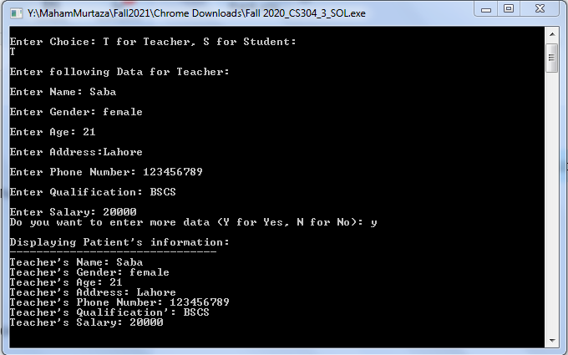

Best of luck!

NOTE: Do not put any query on MDB about this assignment, if you have any query then email at cs304@vu.edu.pk. Furthermore, if any student found cheating from any other student or from online forums then he/she will be awarded ZERO right away and strict disciplinary action will be taken against the student.

Deadline: Your assignment must be uploaded/submitted on or before 15/02/2022

